**University Of Gujrat**

**Name:**

**Mariam Khalid**

**Roll no:**

**18321519-085**

**Class:**

**BS-CS-18(B)**

**Submitted to :**

**DR.Nouman Riaz**

**Code:**

#include <iostream>

#include <fstream>

using namespace std;

class HOD

{

public:

// Attributes

string name, surename, gender;

int age;

public:

// SETTERS

void set_name(string n)

{

name = n;

}

void set_surname(string s)

{

surename = s;

}

void set_gender(string g)

{

gender = g;

}

void set_age(int a)

{

age = a;

}

//GETTERS

string get_name()

{

return this->name;

}

string get_surename()

{

return this->surename;

}

string get_gender()

{

return this->gender;

}

int get_age()

{

return this->age;

}

};

class subject

{

// Attributes

public:

static string data_file;

string subject_name, subject_id;

int crdit_hrs;

// GETTERS

void set_item_name(string n)

{

this->subject_name = n;

}

void set_subject_id(string i)

{

this->subject_id = i;

}

void set_crdit_hrs(int p)

{

this->crdit_hrs = p;

}

// SETTERS

string get_item_name()

{

return this->subject_name;

}

string get_subject_id()

{

return this->subject_id;

}

int get_crdit_hrs()

{

return this->crdit_hrs;

}

string get_data_file()

{

return this->data_file;

}

};

class staff_member : public HOD

{

// Attributes

static string data_file;

string c_id;

public:

// GETTERS

subject p;

void set_staff_memberid(string s)

{

this->c_id = s;

}

//SETTERS

string get_staff_memberid()

{

return this->c_id;

}

string get_data_file()

{

return this->data_file;

}

};

string staff_member ::data_file = "staff_member";

string subject ::data_file = "subject";

class data

{

public:

staff_member C[100];

subject P[100];

int psize, csize;

data()

{

string c_id, name, sure, gend, iname, iid;

int pric, age;

ifstream cfile;

cfile.open("staff_member.txt");

if (cfile)

{

int i = 0;

while (!cfile.eof())

{ // READING staff_member RECORD FROM DATA FILE staff_member.TXT

csize = i;

cfile >> c_id >> name >> sure >> gend >> age >> iid >> iname >> pric;

C[i].set_age(age);

C[i].set_staff_memberid(c_id);

C[i].set_gender(gend);

C[i].set_name(name);

C[i].set_surname(sure);

C[i].p.set_subject_id(iid);

C[i].p.set_item_name(iname);

C[i].p.set_crdit_hrs(pric);

i++;

}

}

else

cout << "ERROR IN CUSTOMR FILE";

cfile.close();

ifstream pfile;

pfile.open("subjects.txt");

if (pfile)

{

int x = 0;

while (!pfile.eof())

{ // READING subject RECORD FROM DATA FILE subject.TXT

psize = x;

pfile >> iid >> iname >> pric;

P[x].set_subject_id(iid);

P[x].set_item_name(iname);

P[x].set_crdit_hrs(pric);

x++;

}

}

pfile.close();

}

//SHOW subject RECORD

void show_item()

{

for (int i = 0; i <= psize; i++)

{

cout << P[i].get_subject_id() << "\t" << P[i].get_item_name() << "\t" << P[i].get_crdit_hrs() << endl;

}

}

//SHOW staff_member RECORD

void show_staff_member()

{

for (int i = 0; i <= csize; i++)

{

cout << C[i].get_age() << "\t" << C[i].gender << "\t" << C[i].get_staff_memberid() << "\t" << C[i].get_gender() << "\t" << C[i].get_name() << "\t" << C[i].get_surename() << endl;

}

}

void search_item()

{

string s;

cout << " ENTER ID ";

cin >> s;

for (int i = 0; i <= psize; i++)

{

if (P[i].get_subject_id() == s)

{

cout << P[i].get_subject_id() << "\t" << P[i].get_item_name() << "\t" << P[i].get_crdit_hrs() << endl;

return;

}

}

cout << "Record not found ";

}

void searc_staff_member()

{

string s;

cout << " ENTER ID ";

cin >> s;

for (int i = 0; i <= csize; i++)

{

if (C[i].get_staff_memberid() == s)

{

cout << P[i].get_subject_id() << "\t" << P[i].get_item_name() << "\t" << P[i].get_crdit_hrs() << endl;

return;

}

}

cout << "Record not found ";

}

void add_staff_member()

{

string c_id, name, sure, gend, iname, iid;

int pric, age;

cout << "Entre staff_member id ";

cin >> c_id;

cout << "entre name ";

cin >> name;

cout << "entre surename ";

cin >> sure;

cout << "Entre gender ";

cin >> gend;

cout << "Entre subject name ";

cin >> iname;

cout << "Entre subject id ";

cin >> iid;

cout << "Entre age";

cin >> age;

cout << "Entre subject crdit_hrs ";

cin >> pric;

csize++;

C[csize].set_age(age);

C[csize].set_staff_memberid(c_id);

C[csize].set_gender(gend);

C[csize].set_name(name);

C[csize].set_surname(sure);

C[csize].p.set_subject_id(iid);

C[csize].p.set_item_name(iname);

C[csize].p.set_crdit_hrs(pric);

}

void delete_staff_member()

{

string s;

cout << "Entre ID";

cin >> s;

int i = 0;

for (i = 0; i <= csize; i++)

{

if (C[i].get_staff_memberid() == s)

{

break;

}

}

while (i < csize)

{

C[i] = C[i + 1];

i++;

}

csize--;

}

void delete_item()

{

string s;

cout << "Entre ID";

cin >> s;

int i = 0;

for (i = 0; i <= psize; i++)

{

if (P[i].get_subject_id() == s)

{

break;

}

}

while (i < psize)

{

P[i] = P[i + 1];

i++;

}

psize--;

}

void update_staff_member()

{

string c_id, name, sure, gend, iname, iid;

int pric, age;

string s;

cout << "Entre ID";

cin >> s;

for (int i = 0; i <= csize; i++)

{

if (C[i].get_staff_memberid() == s)

{

cout << "Entre staff_member id ";

cin >> c_id;

cout << "entre name ";

cin >> name;

cout << "entre surename ";

cin >> sure;

cout << "Entre gender ";

cin >> gend;

cout << "Entre subject name ";

cin >> iname;

cout << "Entre subject id ";

cin >> iid;

cout << "Entre age";

cin >> age;

cout << "Entre subject crdit_hrs ";

cin >> pric;

C[i].set_age(age);

C[i].set_staff_memberid(c_id);

C[i].set_gender(gend);

C[i].set_name(name);

C[i].set_surname(sure);

C[i].p.set_subject_id(iid);

C[i].p.set_item_name(iname);

C[i].p.set_crdit_hrs(pric);

return;

}

}

}

void menu()

{

char c;

while (true)

{

system("cls");

cout << "1.ADD staff_member\n";

cout << "2.Show staff_member\n";

cout << "3.Show subject\n";

cout << "4.Search staff_member\n";

cout << "5.Seach subject\n";

cout << "6.Delete staff_member\n";

cout << "7.Delete subject\n";

cout << "8.Update staff_member\n";

cout << "9.EXIT\n";

cout << "Entre choice ";

cin >> c;

switch (c)

{

case '1':

system("cls");

this->add_staff_member();

system("pause");

break;

case '2':

system("cls");

this->show_staff_member();

system("pause");

break;

case '3':

system("cls");

this->show_item();

system("pause");

break;

case '4':

system("cls");

this->searc_staff_member();

system("pause");

break;

case '5':

system("cls");

this->search_item();

system("pause");

break;

case '6':

system("cls");

this->delete_staff_member();

system("pause");

break;

case '7':

system("cls");

this->delete_item();

system("pause");

break;

case '8':

system("cls");

this->update_staff_member();

system("pause");

break;

case '9':

exit(1);

default:

break;

}

}

}

};

int main()

{

data D;

D.menu();

}

**Output**

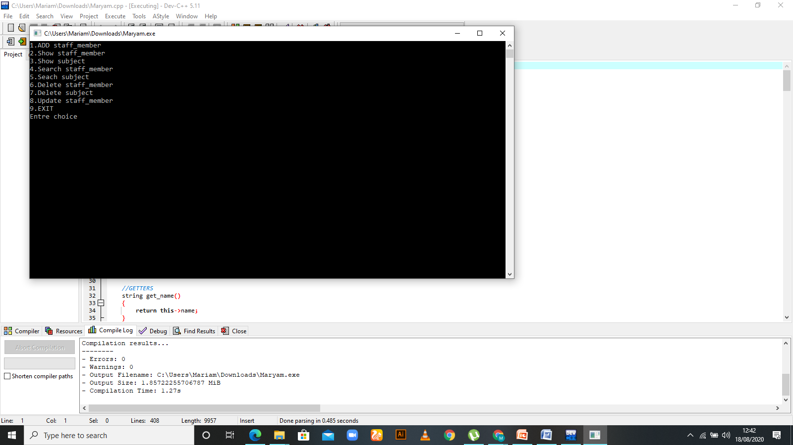

**Output-2**

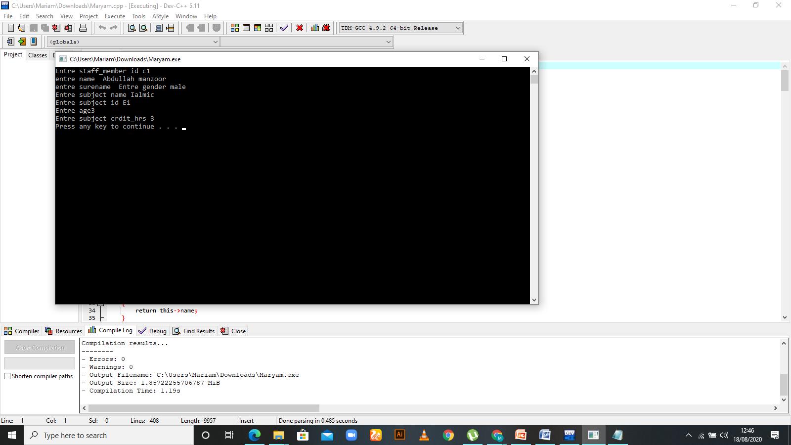

**Staff-Member**

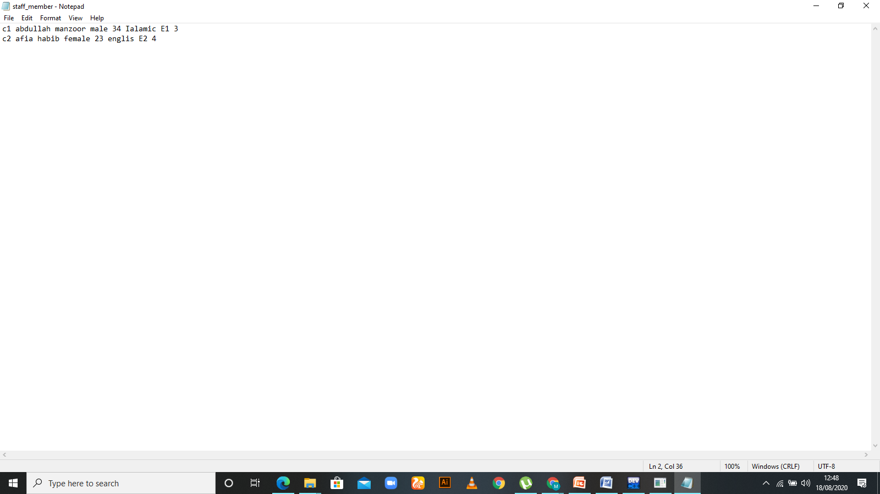

**Subject File**

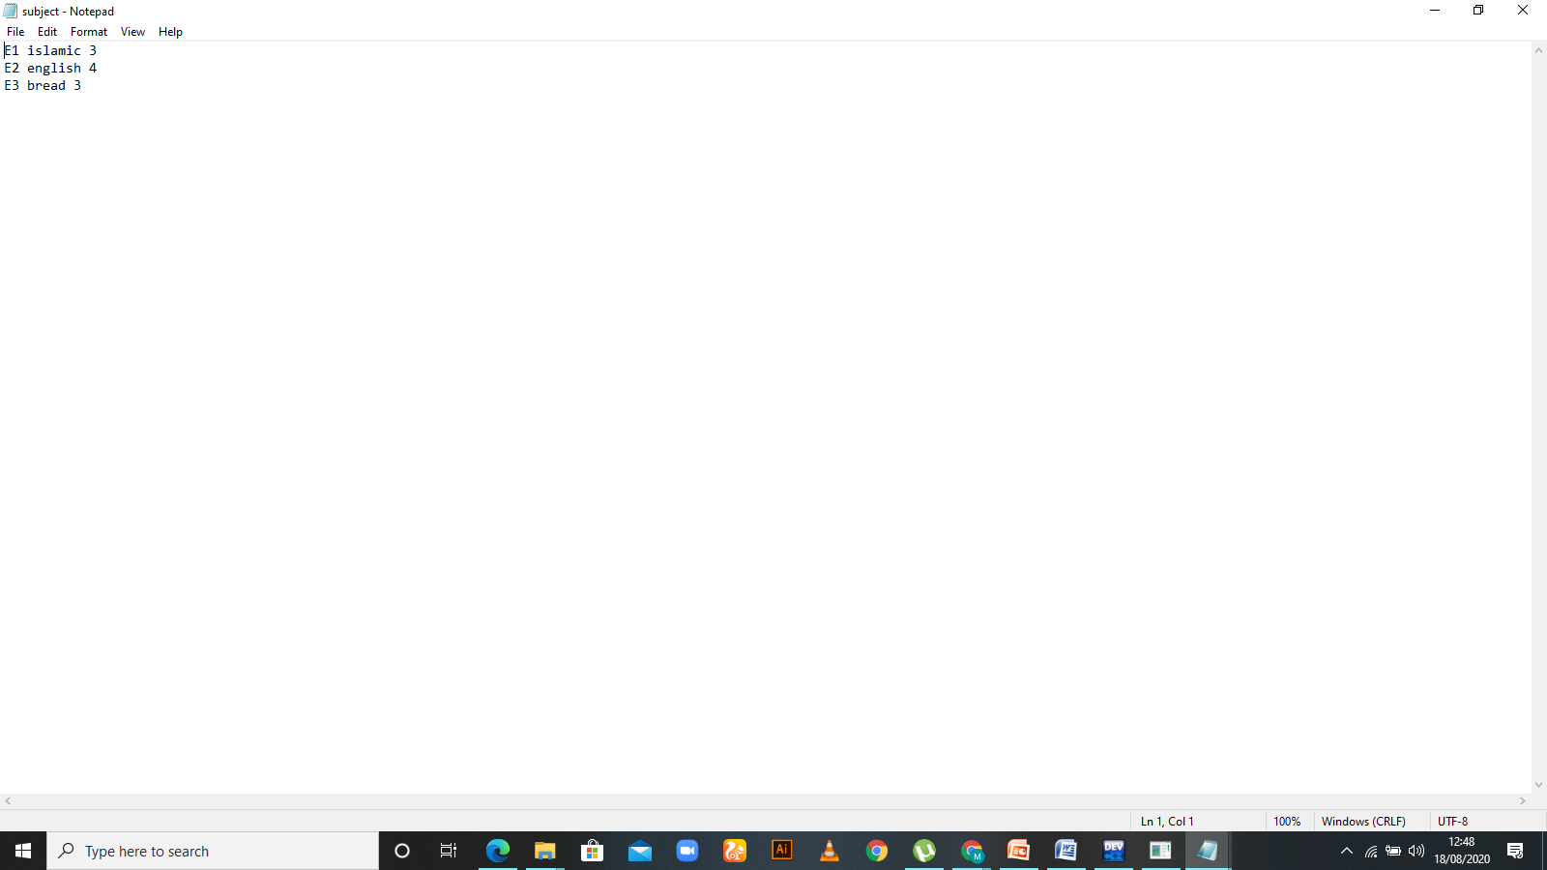

Github Link

<https://github.com/Mariam-mk/paper-18321519-085/upload>